UNIVERSITY OF CAPE COAST
School of Medical Sciences
MED 112 General Physics II (Practical)
Experiment 2
Wheatstone Bridge Experiment
Name: Abigail Naa Ayeley Harding
Student number: SM/SMS/09/0048
Date: Thursday 18th February 2010

TITLE: Determination of the resistance of a wire and the resistivity of a material using the Wheatstone bridge
AIM: To determine the resistance of a wire and the resistivity of a material
APPARATUS: Resistance wire board, Connection box, Slide wire measuring bridge, Standard carbon resistor, Power supply, Digital multimeter and Red, yellow and blue connecting cord
DIAGRAM
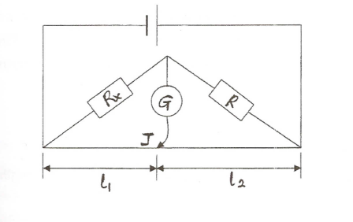
THEORY
The Wheatstone bridge gives a precise method to measure resistance against a known standard. Within a Wheatstone bridge, a comparative device measures two additional relative resistances from two separate resistors. The Wheatstone bridge utilizes repetitive comparisons of potentials to find the equipotential settings. Within this experiment, a multimeter is used as the null detector and is placed as shown in the diagram. When current flows through the multimeter and the jockey is suitably adjusted the current flowing through the multimeter becomes zero. Under these conditions the Wheatstone bridge is said to be balanced or there is “null deflection”. The potential difference across R equals that across the length, l₂ and the potential difference across R_{x} equals l₁ .
Then
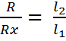 and 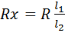

The resistance of the material of the wire is proportional to its length and inversely proportional to its cross-sectional area. That is
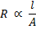

METHOD
The apparatus was set as shown in the diagram. The resistances to be investigated are shown as Rx. Resistor, Q and the Standard resistor, R were connected using the connection box. The power supply was switched on and the connection was checked for correctness by touching the bridge wire at the extreme ends (X and Y) with the slider (jockey), J and observing negative and positive readings of the digital multimeter, G. The balanced point was located on the wire at J, the position where there was zero reading on the digital multimeter. The lengths l₁ from the end X to the balanced point and also l₂ were measured. The measuring instrument G was balanced to zero by moving the slider was balanced to zero. The experiment was repeated with resistance wire of different diameters. The resistances of Q and each of the wires was calculated and for each wire the cross-sectional area A was calculated. The results were tabulated. A graph of resistances of the wires R_{x} against where is the length of the wires was plotted. The slope was determined.

RESULTS
Resistor: 10 Ω
Length of wire: 100 cm
Wire | Diameter, d/mm | Diameter, d/m | l₁ / cm | l₂ / cm | Area /m² | Resistance (R_{x}) / Ω
1 | 1.00 | 0.0010 | 5.5 | 94.5 | 7.854× 10⁻⁷ | 0.582
2 | 0.70 | 0.0007 | 11.0 | 89.0 | 3.848× 10⁻⁷ | 1.236
3 | 0.50 | 0.0005 | 19.8 | 80.2 | 1.963× 10⁻⁷ | 2.469
4 | 0.35 | 0.00035 | 33.7 | 66.3 | 0.962× 10⁻⁷ | 5.083

PLOTTED VALUES
Wire | Resistance, R_{x} /Ω
1 | 0.582 | 1.35 × 10⁶
2 | 1.236 | 2.80 × 10⁶
3 | 2.469 | 5.87 × 10⁶
4 | 5.083 | 11.4 × 10⁶

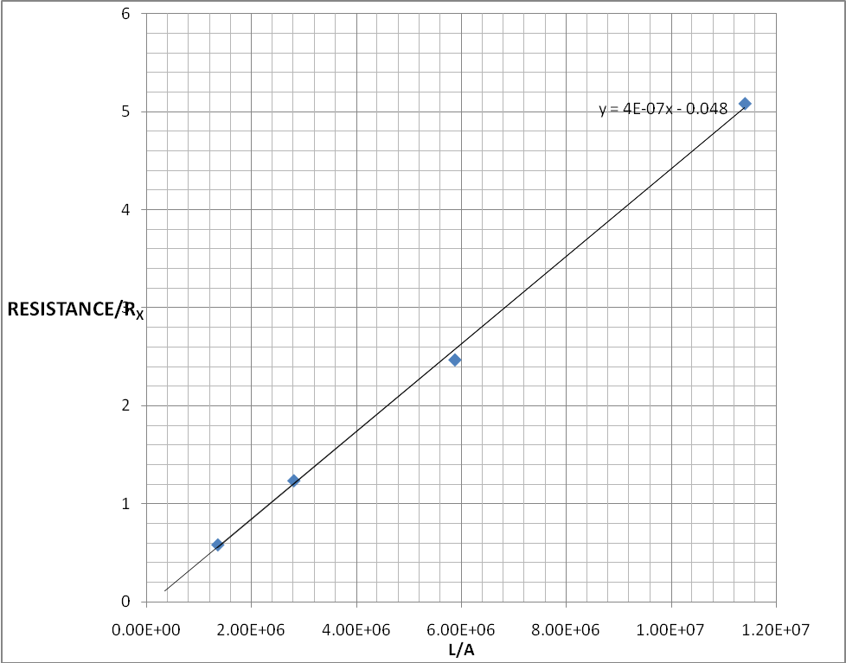
A GRAPH OF RESISTANCE (R_{X}/Ω) AGAINST L/A

CALCULATIONS
R= ρL/ A Comparing this with general equation of a line y=mx+c. y=R, m=ρ and x= l/a

DISCUSSION
SOURCES OF ERROR
PRECAUTIONS
CONCLUSION
REFERENCES
- Young Freedman, (University Physics) 9th Edition, Wesley Publishing Company, page 913.
- Serway & Faughn, (Colllege Physics)

